Grade : /10 NAME:__________________________________
Health 4/5 Quiz 1 – Safety and Responsibility
- A) List ONE school rule that you think is important for kids to follow and why. (Make sure you mention what accidents or consequences might result if students were to break this rule).
B) How can you make sure that other kids follow this rule? /2
________________________________________________________________________________________________________________________________________________________________________________________________________________________________________________________________________________________________________________________________________________________________________________________________________________________________________.
- Below are some common ways that people get hurt in their own homes. For each type of danger, list one example for how that injury or situation might happen OR tell how that situation could be prevented. The first one is done for you as an example. /2
Type of injury/ consequence | Example of how that injury might’ve happened OR one way that the injury could’ve been prevented
Electrocuted | A kid sticks something metal into a light socket.  OR  Make sure that your house has child-safe caps covering the electrical outlets.
Get burnt or start a fire
Trip, fall, or get hit

- For each of the images below, list one safety rule that you should follow while using each type of recreational equipment. / 2
Equipment | Safety rule you should follow:
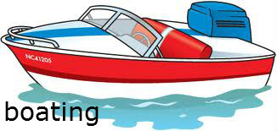
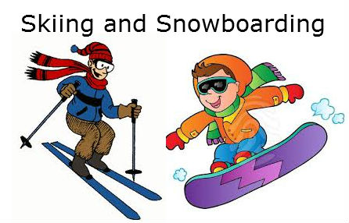

- For each of the following situations, give ONE way that the situation could’ve been avoided OR ONE action to respond to the situation. /4
Situation | Prevention or How to Respond
Drowning
Struck by lightening
Sunburn
Frostbite

