Math 5 Test – Number Patterns and Variables
The grade 5s will be having a math test on WEDNESDAY APRIL 16. The first part of the quiz will be testing them on both number patterns and number relationships (finding a pattern and continuing the trend in a chart). The second part of the quiz will be focused on variables and expressions (solving a problem when one of the numbers is unknown). We will be working on many review activities leading up to the test, and students have some “practice sheets” to help them study. However, I am also including a few examples below as well so that you parents can have an idea of what types of questions may be on the test.
PART ONE: Number patterns and relationships:
- Students will need to observe a set of numbers, a word problem, or a visual that exemplifies how a pattern can be used to predict how a pattern of numbers could be extended.
  - E.g. 15, 20, 25… ____, ______, ______ (continue the pattern for the next 3 numbers)
- Students are also asked to then state the RULE. It is important that when they are stating the rules that they use words instead of symbols, that they state what the pattern started at, and that they try to say “each time” at the end so that we know that this pattern occurs every increment.
  - So, for the example above the rule would be: Start at 15 and increase by 5 each time

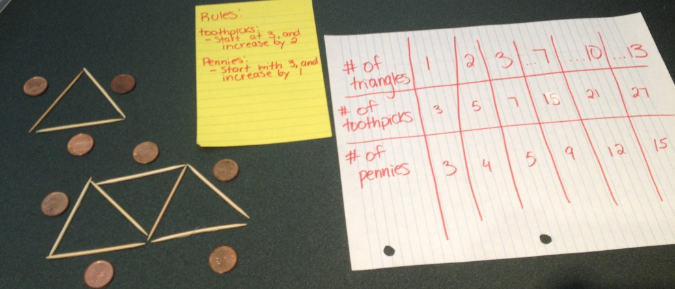
Here is an example of a visual pattern:
- The pattern rule for toothpicks is: Start at 3, increase by 2 each time

- The pattern rule for pennies is: Start at 3 and increase by 1 each time

The trickier pattern questions require the kids to look at a number pattern, then add up a total number by grouping the pattern into “repeated addition” instead of counting rows by rows:
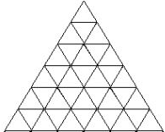
e.g. This triangle has an increasing amount of triangles from the top down. If kids were to chart the number pattern, they would see that the pattern rule for triangles is: starts at 1 and increases by 2 each row, and the numbers would be:

1, 3, 5, 7, 9, 11
By grouping the top row with the bottom(1+11), then the 2nd top with the 2nd bottom (3+9), and then the middle 2 together (5+7), kids can see that the pattern actually creates 12 + 12 + 12 (or 12x3). Therefore, when they are asked to figure out how many triangles TOTAL are in that diagram, they have an alternative method of finding it out rather than counting each triangle.

PART TWO: Variables and Expressions
Students learned that a VARIABLE is any number in a math equation that is expressed by a letter (such as X, N, etc.) because its value is unknown.
An EXPRESSION may contain ordinary numbers, variables (like x or y) and operators (like adding, subtracting, multiplying, and dividing).
X + 5 The whole “X + 5” is an expression.
(Not an equation yet because there isn’t an equal sign in this question)

X is the variable

Students will be given equations such as “Sue is 3 years older that her brother, write an expression to show their ages” which would be b+3 because b=brother, and his age +3 equals Sue’s age. From there, students are given an equation with an equal sign, and they can solve for the unknown number by doing the opposite operation.
For example, in the b+3 example, they might then be told that Sue is 12 years old. They could create an equation to show that b+3=12, and they could subtract 3 from 12 to solve that b(her brother)= 9 years old.
Some questions will simply ask students to write an expression, other questions will ask them to solve for the unknown
E.g. Write an expression for 7 less than a number: __n-7___
E.g. 15 + n = 17, ___n=2__

