Gymnastics

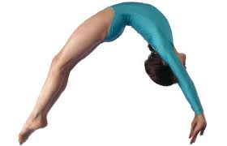

Textbook

BALANCES & SUPPORTS
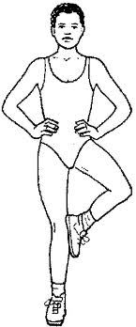  Stork Stand | Knee Scale |  | Arabesque  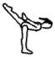
Side Balance  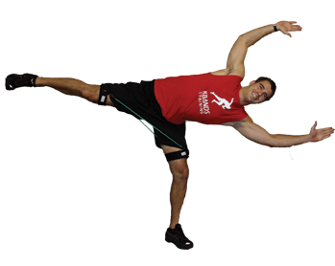 | 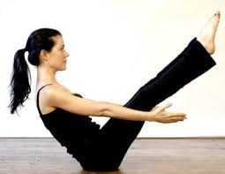  “V” sit |  | “Y” Scale
Monkey Stand | Headstand with Partner |  | Tripod
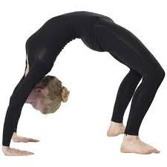  The bridge | 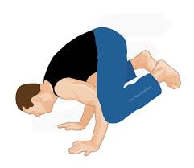  Frog Stand | Shoulder Stand  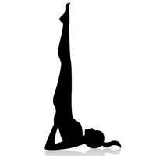

BALANCES & SUPPORTS CONT…
Front Support |  | Side Support |  | Back Support  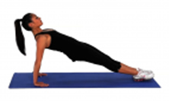
Superman  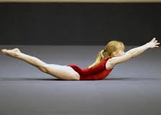 |  | Shoulder Toe Balance  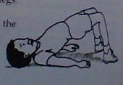 |  | Knee Grab  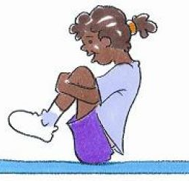
Knee Bird | Broken Airplane (one leg down, opposite hand down) |  | Falling Comet

JUMPS
Pencil Jump  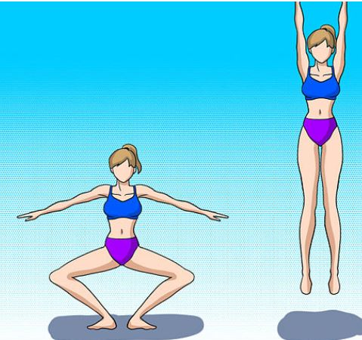 |  | Star Jump  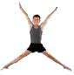 |  |  | Spin Jump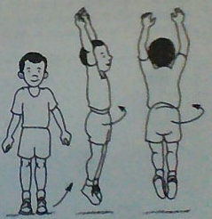
Straddle Jump  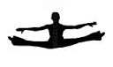 |  | Split Jump  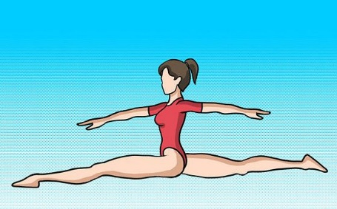 |  |  | Pike Jump  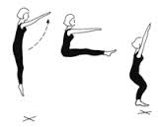
Bum Kick | 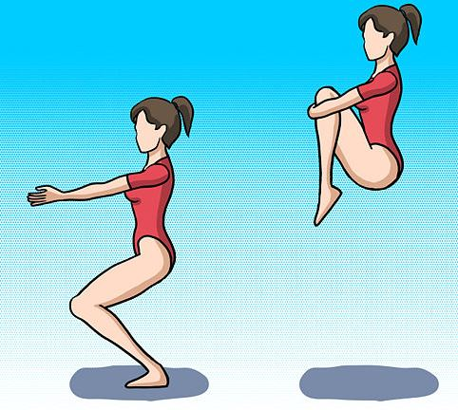  Tuck Jump |  |  | Straddle jump over an obstacle  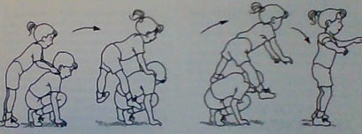
Tuck to Front Support (or front support to tuck) 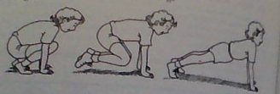 |  |  | Straddle to front support (or front support to straddle) 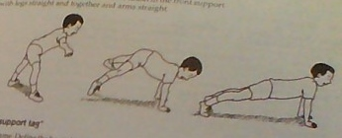
Frog Jump (Feet Apart)  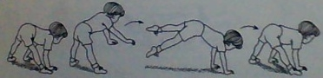 |  |  | Frog Jump (Feet Together)  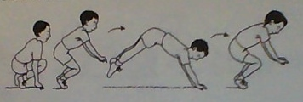

ROLLS
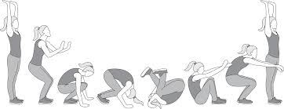  Somersault | 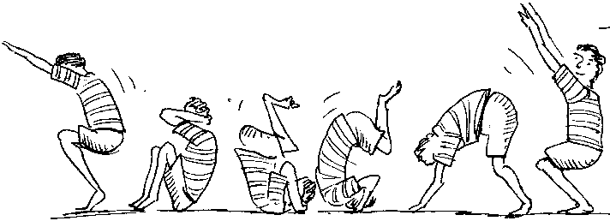  Backwards Roll |  |  |  | Shoulder Roll 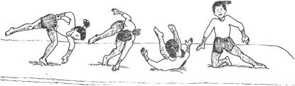
Cartwheel  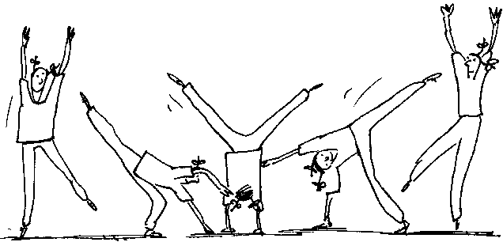 |  |  |  | 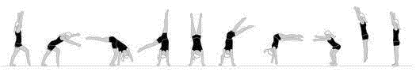  Round-off (Cartwheel landed sideways)
Dive Roll  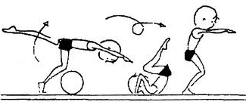 |  | Log Roll |  |  |  | Side-tuck Roll
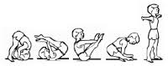  Straddle Roll |  |  | Front support (side) to Back Support

PARTNER SUPPORTS
Wheel Barrow (wheel barrow)  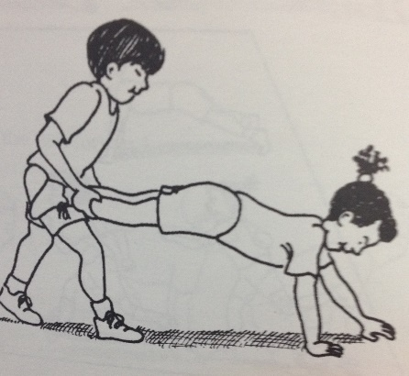 | 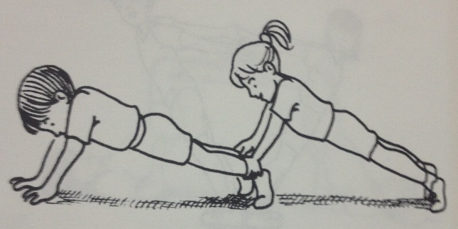  Heel to Heels (stairs)
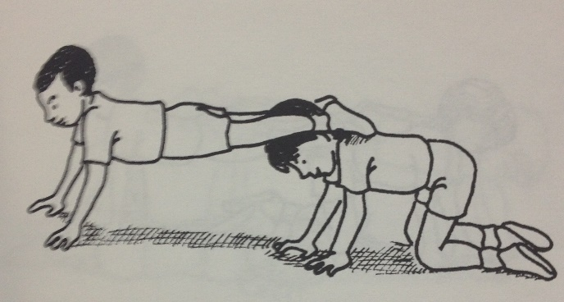  Shin to Neck (Table) | Shin to Back (open drawer)  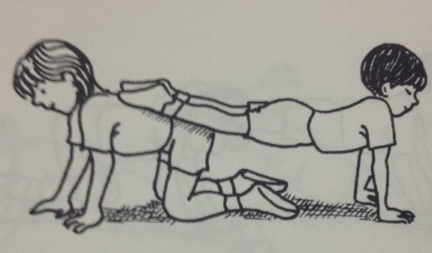
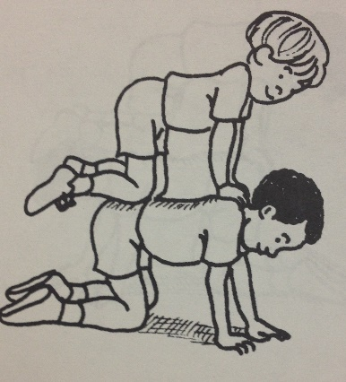  2-man pyramid (ladder) | 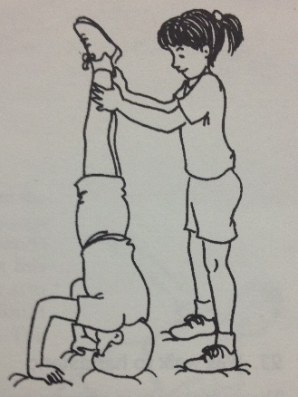  Head Stand
Backwards 2-man pyramid  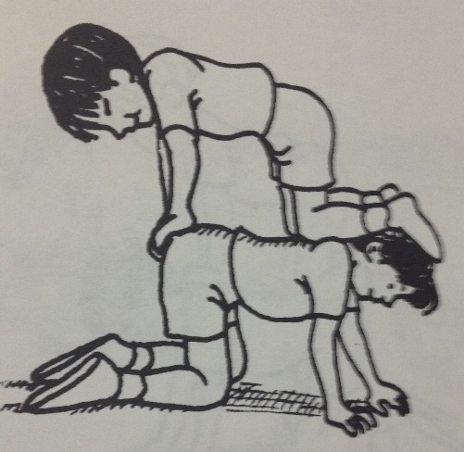 | Pyramid  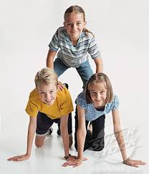
(Terms in brackets are “calls” for a game)

PARTNER COUNTER-BALANCES
1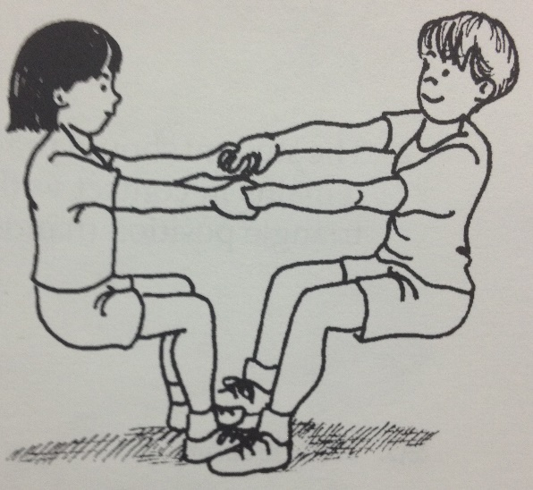 |  | 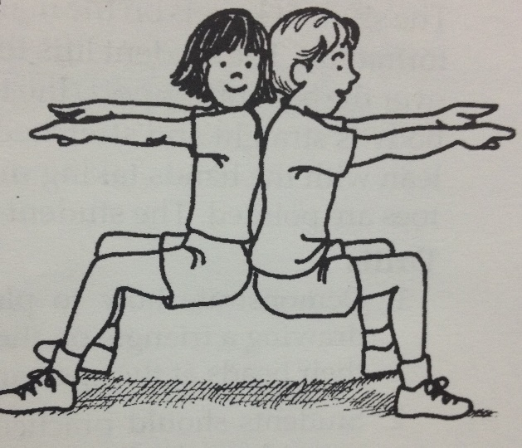
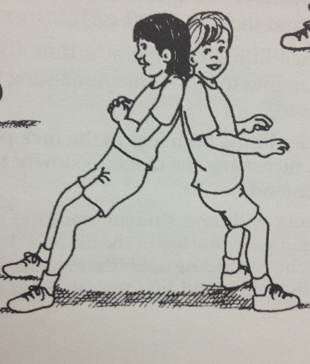 | 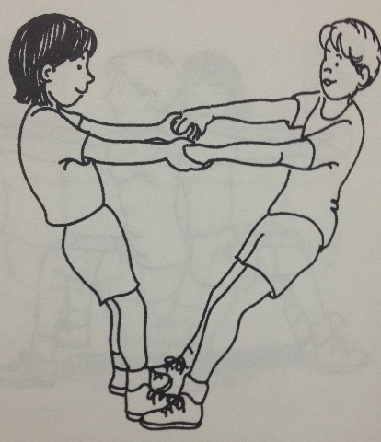 |  | 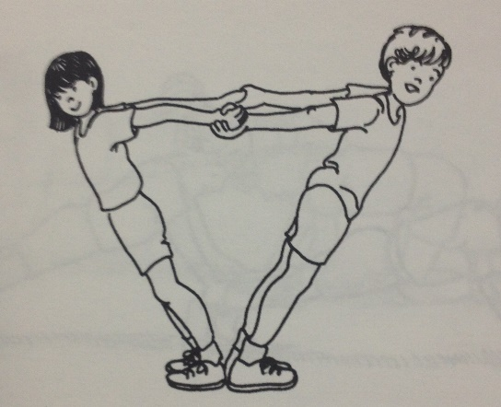
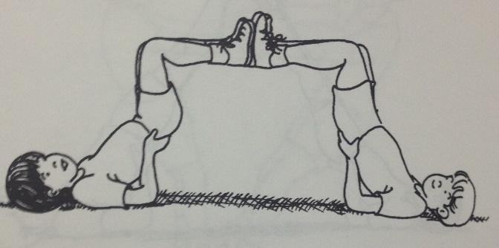 |  | 